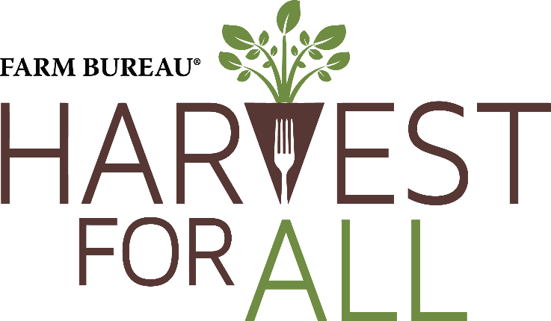

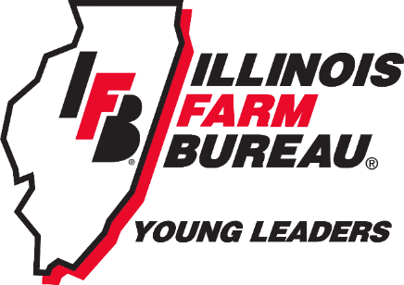

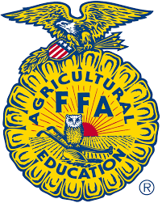

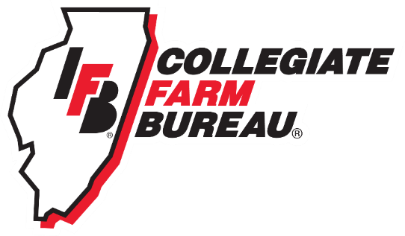

Who is involved?
In 2002, American Farm Bureau Federation (AFBF) Young Farmers & Ranchers (YF&R) Committee implemented Harvest for All – a program that focuses on fighting food insecurity in our communities through food, friends, and funds. Today, the Illinois Farm Bureau Young Leaders (members ages 18-35) spearhead this initiative in our state and partner with FFA and Collegiate Farm Bureau chapters to maximize their reach.
Food – pounds of food donated
Friends – hours volunteered
Funds – dollars raised
How does it work?
Each year, there is a tracking period that runs from May 1 – April 30 (to best align with the school year). During this tracking period chapters record pounds of food donated, dollars raised, and hours volunteered. Towards the end of the tracking period, IFB staff will provide a form for chapters to submit their final calculations. These calculations contribute to our overall reach, and then our Young Leaders compete as a state for awards with the collective total.
Where can we donate?
Your schools and your communities! Whether you are a collegiate chapter and have a campus food pantry, an FFA chapter with a collection box in your hallways, or donating to a regional food bank, you can serve your neighbors and community members fighting food insecurity.
Why does the Harvest for All program exist?
To demonstrate the generosity of Illinois agriculture by serving those in your community who need it most.
Example Timeline: (Dates subject to change)
May 1, 2023 – tracking begins.
Around April 1, 2024 – IFB staff sends out a form to record pounds of food donated, dollars raised, and hours volunteered.
April 30, 2024 – Tracking form sent by IFB staff is due. These calculations are added to any Young Leader efforts thus far.
February 2025 – Illinois Farm Bureau Young Leader totals due to AFBF.
March 8-11, 2025 – Harvest for All awards presented during AFBF YF&R Conference.
Potential Ideas:
- Fill a Ford, partner with your county Farm Bureau YL group and/or other businesses
- Raffle – sell raffle tickets for a unique prize, the monetary donations go towards a food bank
- If you have a greenhouse and grow produce, donate it
- Use a portion of your officer retreat or chapter meeting to volunteer at a food bank
- Have non-perishable food brought in at each chapter meeting and donated
- If your FFA chapter participates in an Acquaintance Day, suggest volunteering as part of the agenda
Tips for a Successful Event:
- Schedule the activity in conjunction with a popular event, such as a county or state fair, local sporting event, rodeo, Farm Bureau conference, etc.
- Consider providing a giveaway item or prize in order to increase participation. For example, give a Farm Bureau t-shirt to the first 50 people who donate a non-perishable food item or have them enter their name into a raffle for a prize.
- Reach out to local businesses to sponsor your activity, donate prizes or giveaway items. For example, you could team up with a local dealership to “fill the truck” with donated food.
- More ideas: 5K run/walk, t-shirt sales, bake sale, raffle, or golf tournament.
- The activity can also be as simple as a service project at a local food charity. Most food charities appreciate any extra help to help with stocking shelves, packing boxes, or distributing foods..
- If you plan to donate food, contact your local food charity to find out what food items they will accept and to coordinate the delivery of the donation to their facility. A representative of the food charity may also want to attend your event.
- Most importantly, be creative and have fun!

